Election of 1860
Candidate | Abraham Lincoln | Stephen Douglas | John Breckinridge | John Bell
 | 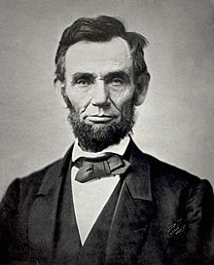 | 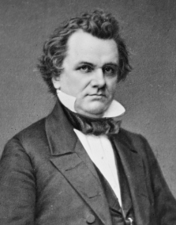 | 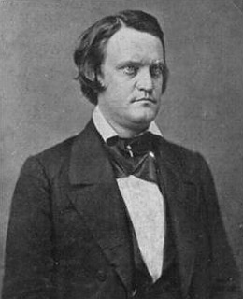 | 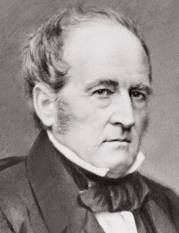
Party | Republican | Democrat | Democrat | Constitutional Union Party
Home State | Illinois | Illinois | Kentucky | Tennessee
Previous Experience | Representative (1845-47) | Representative  (1842-46)  Senator  (1846-60) | Representative (1845-57)  Vice President  (1857-1861) | Representative (1827-41)  Senator  (1841-59)
Slavery | No slavery in the territories. Allow it to remain in states where it exists. | Popular Sovereignty in the territories. Slavery is allowed under the U.S. Constitution | Supports Dred Scott Decision. Slavery is allowed in states where it already exists and the territories | No Position on slavery in the territories. Said he would follow the Constitution with regard to the slavery issue.
Land in the West | Support free homesteads in west for settlers | Opposed to free homesteads | Opposed to free homesteads in west  Supported acquisition of Cuba so that it could become another slave state. | No Position

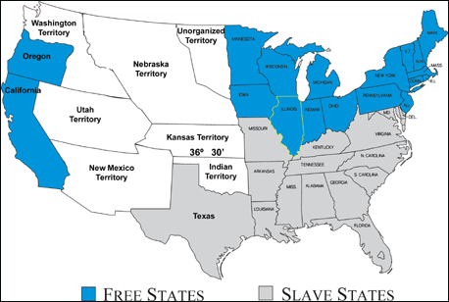
West – Oregon, California Minnesota, Wisconsin, Iowa
Border States – Missouri, Kentucky, Tennessee, Virginia, Maryland, Deleware

ELECTION OF 1860
Assignment:
- For which candidate would each of the following regions have most likely voted? Why?

North –

South –

West –

Border States –

Examine the map and chart on the back of this page and answer the questions below.

- To what extent were your predictions accurate?

- About what percent of the popular vote did Lincoln win? Electoral vote?

- How was Lincoln able to win so many electoral votes while winning such a small percentage of popular votes?

ELECTION OF 1860 - RESULTS
